**Dashboard Design**

|  |  |
| --- | --- |
| Date | 24 June 2025 |
| Team ID | PNT2022TMIDxxxxxx |
| Project Name | Predicting plant growth stages with environmental and management data using power bi |
| Maximum Marks | 5 Marks |

Creating an effective dashboard involves thoughtful design to ensure that the presented information is clear, relevant, and easily understandable for the intended audience. Here are some key principles and best practices for dashboard design

**Activity 1: Interactive and visually appealing dashboards**

Creating interactive and visually appealing dashboards involves a combination of thoughtful design, effective use of visual elements, and the incorporation of interactive features. Here are some tips to help you design dashboards that are both visually appealing and engaging for users so take care of below points

* Clear and Intuitive Layout
* Use Appropriate Visualizations
* Colour and Theming
* Interactive Filters and Slicers
* Drill-Down Capabilities
* Responsive Design
* Custom Visuals and Icons
* Use of Infographics

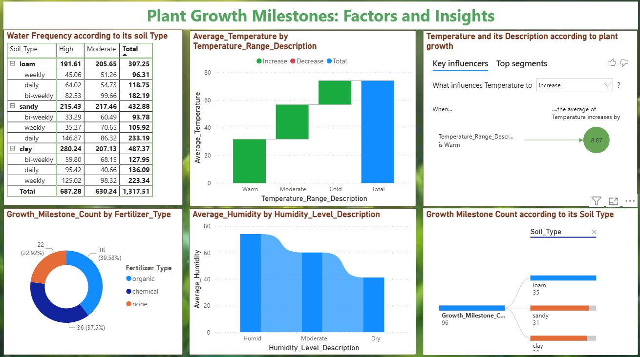

**Note:** Highlight the major outcomes in form of bullet points

Sample:

*Here are* ***six*** *potential outcomes from the dashboard image provided:*

**1. Loam Soil Supports Highest Plant Growth Milestones**

The **Growth Milestone Count by Soil Type** visual shows that **loam soil** accounts for the highest number of growth milestones (35), followed by sandy (31) and clay (30). This indicates that loam provides a well-balanced texture and optimal conditions for plant development compared to other soil types.

**2. Warm Temperatures Significantly Boost Plant Growth**

From both the **Average Temperature by Temperature Range Description** and the **Key Influencers visual**, it is clear that **warm temperature** conditions result in a significant **increase in plant growth**, with an average temperature increase of **8.87** units. This suggests that managing environmental temperature can be critical for maximizing yield.

**3. Chemical Fertilizers Yield Slightly Better Results**

The **Growth Milestone Count by Fertilizer Type** donut chart shows that **chemical fertilizers** contribute to the highest milestone count (38), followed closely by **organic fertilizers** (36). This outcome highlights the effectiveness of fertilization—particularly chemical and organic types—in promoting plant growth.

**4. Clay Soil Requires the Most Frequent Watering**

Based on the **Water Frequency according to its Soil Type** table, **clay soil** has the highest total water requirement (487.37), particularly in the **daily and weekly categories**. This implies that while clay supports growth, it demands more water due to its dense structure and slower drainage.

**5. Humid Conditions Favor Higher Growth Potential**

The **Average Humidity by Humidity Level Description** chart shows that **humid conditions** have the highest average humidity (around 75%), which is ideal for plant growth. Plants in humid environments are less prone to water stress, supporting healthier development and more milestones.

**6. Interactive Analysis Enables Deeper Insights**

With visuals like the **decomposition tree** and **key influencer analysis**, users can interactively explore how each variable—such as soil type or temperature—affects outcomes. These features enable more personalized insights and real-time decision-making for optimizing plant growth conditions.